

Programme Name: ________**BCS HONS**_______________________________________

Course Code: __**CSC 2514**________

Course Name: _______**Web System and Technologies**_____________________________

**Individual Project** _**1**___

Date of Submission: ______**9/10/2021**_____________

**Submitted By: Submitted To:**

Student Name**: Dipesh Tha Shrestha** Faculty Name**: Prakash Chandra**

IUKL ID: **041902900028** Department**: LMS**

Semester**: Fourth Semester**

Intake**: September 2019**

**PROJECT TITLE: E-COMMERCE WEB APPLICATION**

**(Dipesh Ko Pasal)**

**Table of context**

* **Abstract**
* **Introduction**
* **TOOLS AND TECHNOLOGIES**
* PHP
* JAVASCRIPT
* Html/Html5
* CSS 3
* Bootstrap
* MySQL
* XAMPP
* **Features**
* **Administrators Detailed Attribute**
* **Customer Detailed Attribute**
* **Testing**
* Interface layout
* Homepage
* registration page
* Login
* Shopping Chart
* **Database**
* **Conclusion**
* **Appendix**

**Abstract**

The purpose of this project was to develop an e-commerce we application by using open source technologies (PHP, HTML5, CSS3, JavaScript, MySQL and Apache Web Server) where customers will be able to buy products online. Dipesh Ko Pasal is a Business to Consumer Online E-commerce application which is designed for creating a smart online shopping opportunity for consumers. This shopping platform has a lot features for consumers. This system is designed for makes shopping easy and convenient for buyers. By using the web application buyers and sellers will be benefited. The project is developed by the most popular web programming language PHP. The user-friendly interface and functionality helps users and admin to manage the application easily. It basically helps Customers who want to buy their necessary products in a user-friendly manner. The customers can simply visit the system, choosing products from any category, register for order, log in to their accounts and finally can make payment of their purchased amount.

**Introduction**

In our daily lives, computers play an important role. We can get anything we want with just one mouse click. The computer's speed, dependability, and accuracy make it a useful tool for a variety of tasks. The quick availability and processing of information using computers is a very important and basic need in today's modern business world. Within a fraction of a second, one can obtain the type of information required. This is also the category in which my project falls, as it is used in our daily lives when we want to buy something that we can easily get at home.

E-commerce (also known as electronic commerce or EC) is the buying and selling of goods and services, as well as the transmission of funds and data, over an electronic network, most commonly the internet. Business-to-business, business-to-consumer, consumer-to-consumer, and consumer-to-business transactions are all possible. E-commerce stores have become an integral part of our lives. People can now shop online from the comfort of their own homes rather than going to a physical store thanks to technological advancements.

**TOOLS AND TECHNOLOGIES**

These are the necessary tools and materials needed to build the website both the frontend and the back-end. These include software and open source materials.

**PHP**

PHP is a server-side scripting language that is used to develop Static websites or Dynamic websites or Web applications. It is designed for web development to implement dynamic web pages and can be embedded into HTML for it to be displayed.

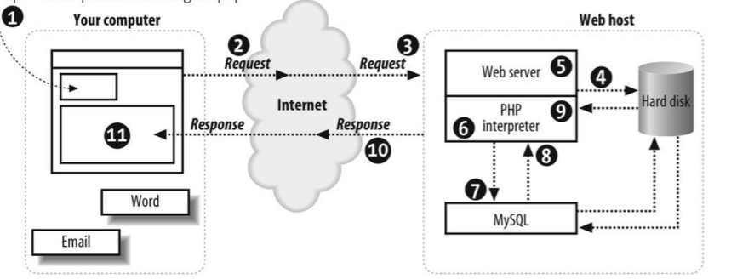

Fig: Demonstrating how the web server Operates using PHP

**JAVASCRIPT**

JavaScript is a high-level language which could be used independently or inculcated into the webpage. It can be used to, handle requests and responses and also add dynamic behavior and also store information on a website. JavaScript often abbreviated as JS, is a high-level, interpreted programming language. It is a language which is also characterized as dynamic, weakly typed, prototype-based and multi-paradigm. Alongside HTML and CSS, JavaScript is one of the three core technologies of the World Wide Web. JavaScript enables interactive web pages and thus is an essential part of web applications. The vast majority of websites use it, and all major web browsers have a dedicated JavaScript engine to execute it.

**Html/Html5**

HTML means Hypertext Markup Language. This language is used in creating web pages. This language also supports other languages such CSS, PHP, JAVASCRIPT, etc. in creating interactive and responsive pages on the pages. HTML5 is just an updated version of the HTML. It supports new features, new attributes, new HTML elements, full CSS3 support, video and audio, 2D/3D graphics that help users and also help web developers to create new features easily on the website.

**CSS 3**

Cascading Style Sheets (CSS) is a style sheet language used for describing the presentation of a document written in a markup language like HTML. CSS is a cornerstone technology of the World Wide Web, alongside HTML and JavaScript. CSS is designed to enable the separation of presentation and content, including layout, colors, and fonts. This separation can improve content accessibility, provide more flexibility and control in the specification of presentation characteristics, enable multiple web pages to share formatting by specifying the relevant CSS in a separate css file, and reduce complexity and repetition in the structural content.

**Bootstrap**

Bootstrap is a free and open-source front-end framework for designing websites and web applications. It contains HTML- and CSS-based design templates for typography, forms, buttons, navigation and other interface components, as well as optional JavaScript extensions. Unlike many web frameworks, it concerns itself with front-end development only.

**MySQL**

MySQL is a free source database system, and it enables the cost-effective delivery of reliable and a high-performance and scalable Web-based and embedded database applications. It is a relational database system(RDBMS). It is a high performing program and scalable to meet the demands of users and data. MySQL is written in C and C++, so it is compatible with most of the operating systems available around the world.

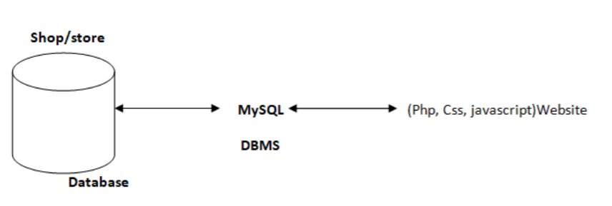

Fig: Showing the concept of MySQL

**XAMPP**

XAMPP is a free and open source cross-platform web server solution stack package developed by Apache Friends, consisting mainly of the Apache HTTP Server, MariaDB database, and interpreters for scripts written in the PHP and Perl programming languages. XAMPP stands for Cross-Platform (X), Apache (A), MariaDB (M), PHP (P) and Perl (P). It is a simple, lightweight Apache distribution that makes it extremely easy for developers to create a local web server for testing and deployment purposes. Everything needed to set up a web server – server application (Apache), database (MariaDB), and scripting language (PHP) – is included in an extractable file. XAMPP is also cross-platform, which means it works equally well on Linux, Mac and Windows. Since most actual web server deployments use the same components as XAMPP, it makes transitioning from a local test server to a live server extremely easy as well.

**Feature:**

Here is some important feature of this website:

* Sign in/Sign up system.
* Search
* Product navigation and search by appropriate categories and sub-categories.
* Shopping cart
* Proper checkout.
* Authentication and authorization
* Online Transactions.
* Categories Divided.

The user must first Login/Sign Up to the site and then search for the products they desire, or simply browse the product categories. It’s easy to operate and understand by users. The design is pretty simple and user won’t find it difficult to understand, use and navigate.

**Administrators Detailed Attribute**

The administrator has all the rights to access the system. He is the one who has all rights to view the members and product details, modify those details. He can add various product based on the category. He can also set the available quantity of a product and its reasonable price. Also he can also set discount in various occasion. Admin can also view the details of a member. The admin has the power to generate the scratch card so that users can also use the recharge card to buy various product.

**Customer Detailed Attribute**

The user can log in to the system by using his specific email and password. User can view the products and order the products according to their own needs. He can view his profile and update his details. He can update his personal information by logging into the system. User can find various product by using search option easily. update his details. He can update his personal information by logging into the system. User can find various product by using search option easily. Customer can do the following task:

* Sign up This refers to registering as a customer. The registered member has a lot of privileges associated with the shop when one becomes a customer.
* Login After the user has registered, the user becomes a customer, and he or she can log in with their personal information.
* View The customer can see all the products in the catalog and able to look at the products and some features on the homepage.
* Edit The customer can make changes to their password
* Update Cart This refers to putting or removing products from a shopping cart.

**Testing**

I checked the reliability of all of the functions to ensure that the e-commerce web application assessments had been made at various stages of the project. The customer/user and Management Unit are the foundations of the test. The customer test demonstrated that an account could be created, that a login could be established, that a cart could be loaded with products, and that the customer could check out once they were finished shopping.

**Interface layout**

The homepage or interface is the index page of the shop so can be accessed when the address is typed into a browser. The webpage has products images, names, prices, product categories and product brands.

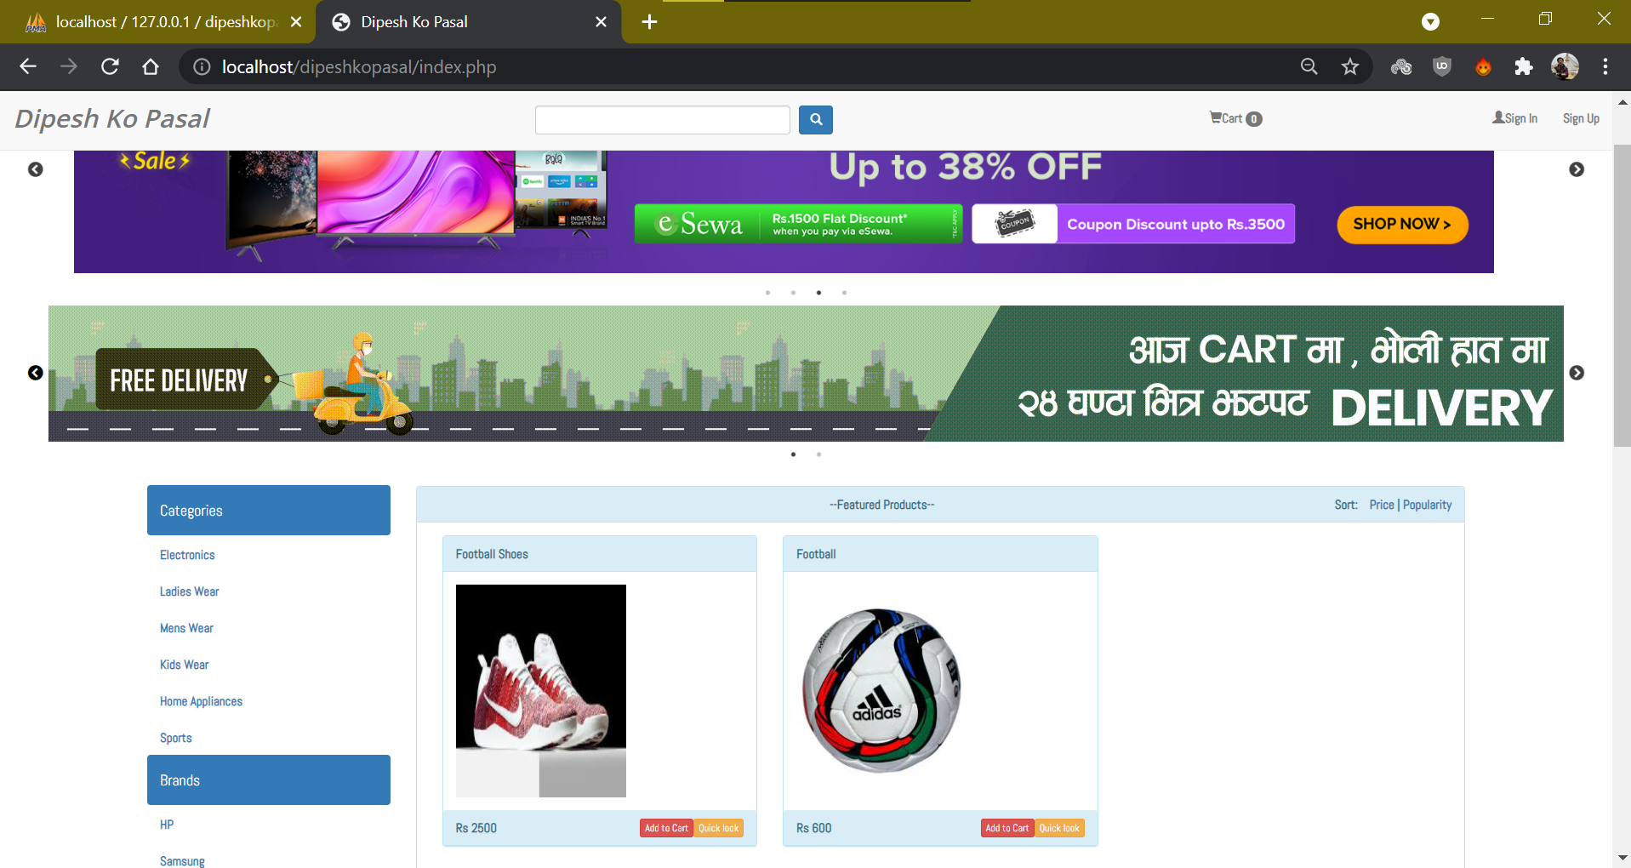

Fig: Homepage

**Registration**

This page is only for users who want to register as customers. To register successfully, they must meet the required filled standard; otherwise, they will remain on the same page. Their information is saved directly to the "user_info" when they register. A code editor is used to run the registration file "customer registration.php."

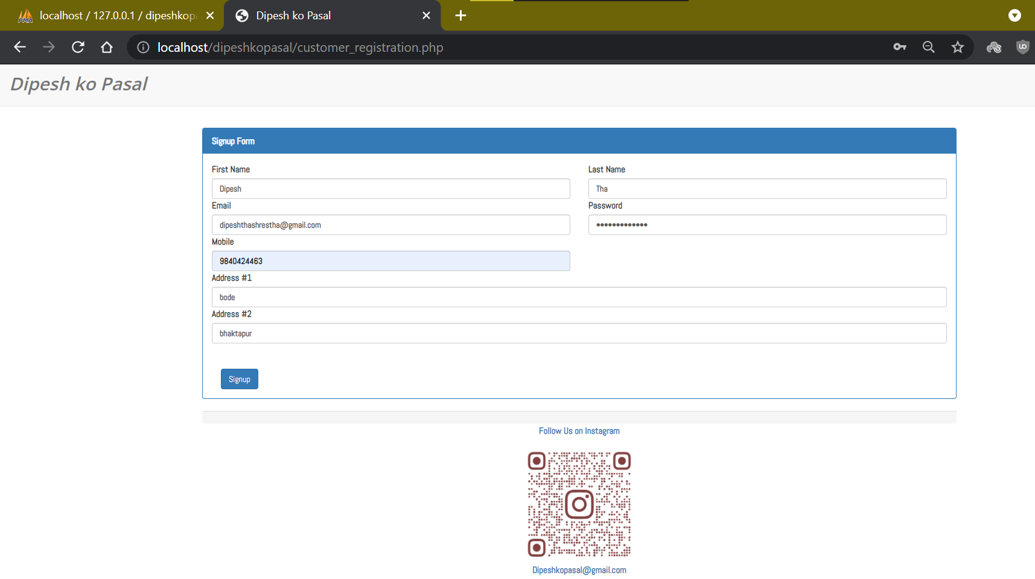

Fig: Customer registration page

**Login**

Customers will be able to log in using their personal information, such as their e-mail address and password. To see if there is a match, the information is sent to the database. If there is no match, the customer is returned to the previous page; otherwise, he is directed to the customer page.

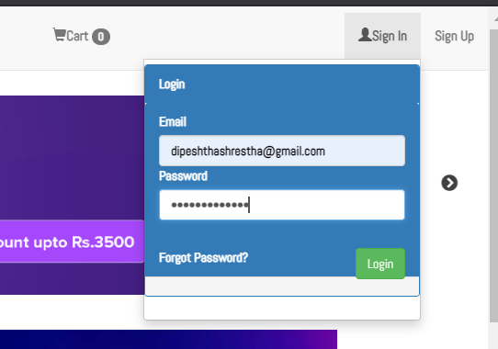

Fig: before Login

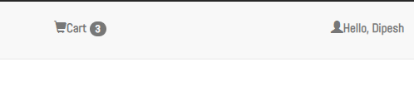

Fig: After Login

**Shopping Cart**

Products can be added to the shopping cart by the customer. They can also update their shopping cart until they are finished shopping. Following that, they can check out by selecting the profile and then chart button.

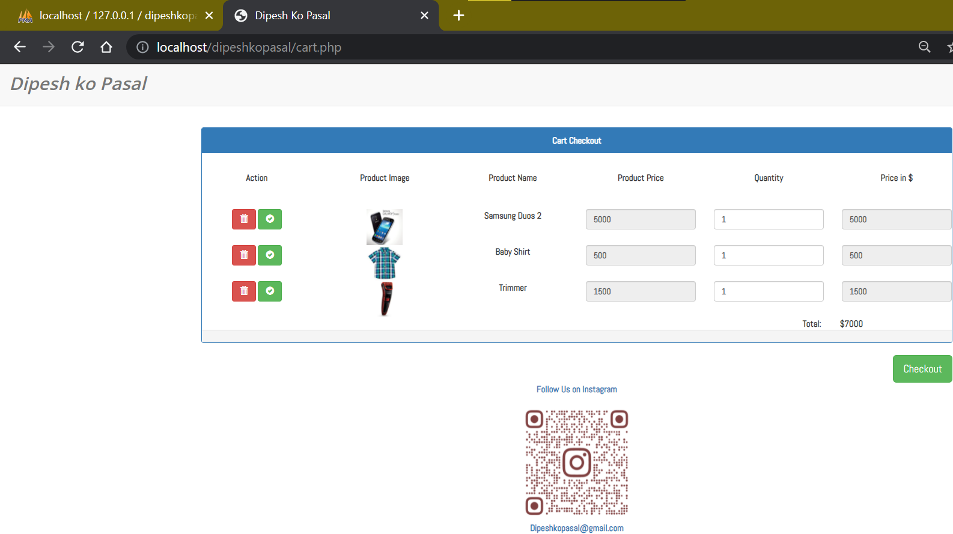

Fig: Shopping Chart

**Database**

MySQL database is used to save software data for this project. MySQL is relational database management, and it is free of charge. All of the information is kept in a selected table, and every table has particular range columns and rows. It has seven tables named as, brands, cart, categories, customers_orders, products, received_payment and user info.

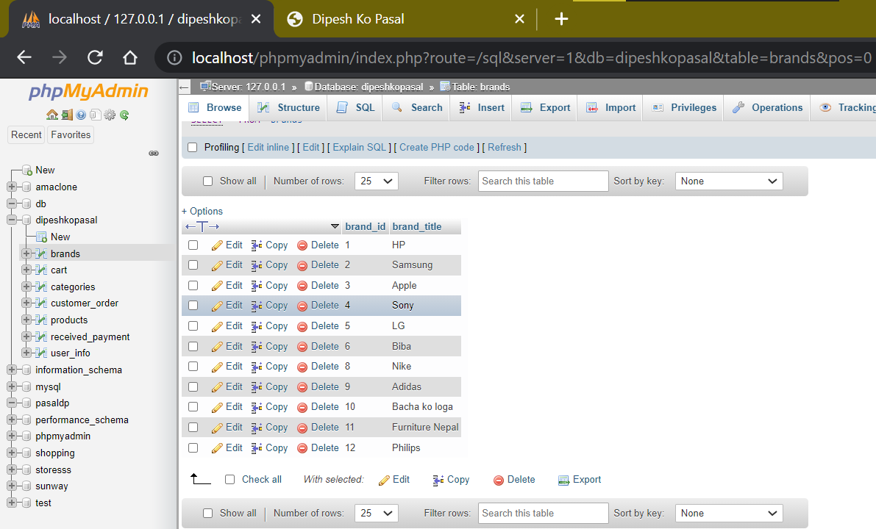

Fig: Database table showing various brands

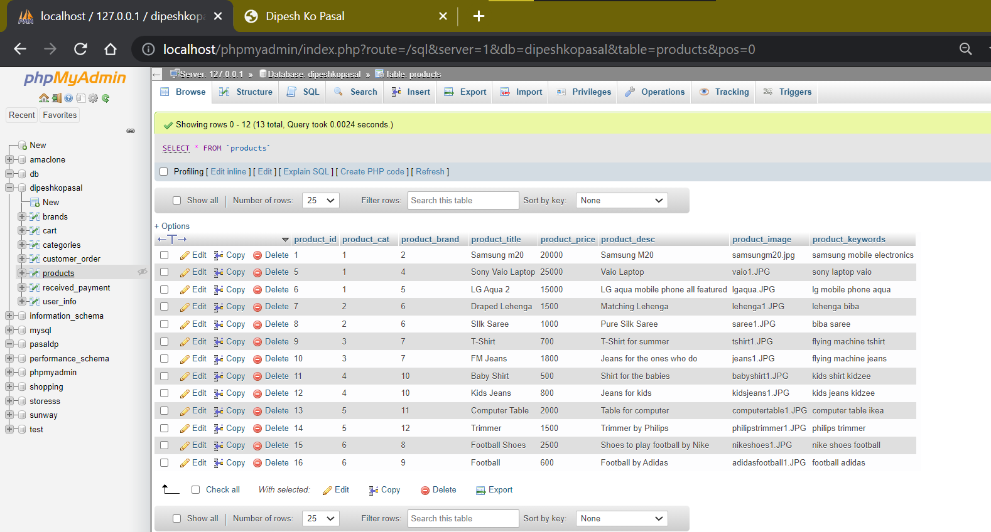

Fig: Database table showing various product

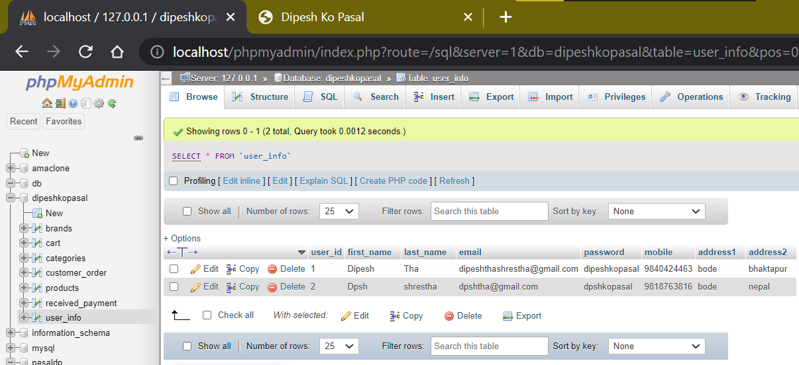

Fig: Database showing user information

**Conclusion**

The project was created using PHP and MySQL and is based on the user's requirements and an analysis of the existing system, with flexibility for future enhancement. The increased functionality of today's software necessitates a more thoughtful approach to software development. This ecommerce software was created with you in mind. PHP, CSS, HTML and JavaScript are used to create the e-commerce site. When it comes to the project, it has all of the necessary features. On the administration side, he or she can view sales, number of products, users, daily sales report, and add products and categories, while On the user side, he or she can view product categories, add products to cart, and proceed to checkout.

**Appendix**

In this I have mention some important code used in this website.

**Index.php**

<?php

    session_start();

    if(isset($_SESSION['uid'])){

        header('location:profile.php');

    }

 ?>

<!DOCTYPE html>

<html>

<head>

    <meta charset="utf-8">

    <title>Dipesh Ko Pasal</title>

    <link rel="stylesheet" type="text/css" href="http://kenwheeler.github.io/slick/slick/slick.css"/>

    <link rel="stylesheet" type="text/css" href="http://kenwheeler.github.io/slick/slick/slick-theme.css"/>

    <link rel="stylesheet" type="text/css" href="assets/bootstrap-3.3.6-dist/css/bootstrap.css">

    <link rel="stylesheet" type="text/css" href="styles.css">

</head>

<body>

    <div class="navbar navbar-default navbar-fixed-top" id="topnav">

        <div class="container-fluid">

            <div class="navbar-header">

                <a href="index.php" class="navbar-brand">Dipesh Ko Pasal</a>

            </div>

            <ul class="nav navbar-nav">

                <li style="width:300px;left:10px;top:10px;"><input type="text" class="form-control" id="search" name=""></li>

                <li style="top:10px;left:20px;"><button class="btn btn-primary" id="search_btn" name=""><span class='glyphicon glyphicon-search'></span></button></li>

            </ul>

            <ul class="nav navbar-nav navbar-right">

                <li id='shoppingcart'><a href="#" class="dropdown-toggle" data-toggle="dropdown"><span class="glyphicon glyphicon-shopping-cart"></span>Cart <span class="badge">0</span>   </a>

                    <div class="dropdown-menu" style="width: 400px;">

                        <div class="panel panel-success">

                            <div class="panel-heading">

                                <div class="row">

                                    <div class="col-md-3">S. No.</div>

                                    <div class="col-md-3">Product Image</div>

                                    <div class="col-md-3">Product Name</div>

                                    <div class="col-md-3">Price in $</div>

                                </div>

                            </div>

                            <div class="panel-body"></div>

                            <div class="panel-footer"></div>

                        </div>

                    </div>

                </li>

                <li><a href="#" class="dropdown-toggle" data-toggle="dropdown"><span class="glyphicon glyphicon-user"></span>Sign In</a>

                    <ul class="dropdown-menu">

                    <div style="width: 300px;">

                        <div class="panel panel-primary">

                            <div class="panel-heading">Login</div>

                            <div class="panel-heading">

                                <label for="email">Email</label>

                                <input type="email" class="form-control" id="email">

                                <label for="email">Password</label>

                                <input type="password" class="form-control" id="password">

                                <p><br></p>

                                <a href="#" style="color: white;list-style-type: none;">Forgot Password?</a>

                                <input type="submit" class="btn btn-success" style="float: right;bottom:12px;" id="login" value="Login" name="">

                            </div>

                            <div class="panel-footer" id="e_msg"></div>

                        </div>

                    </div>

                </ul>

                <li><a href="customer_registration.php">Sign Up</a></li>

            </ul>

        </div>

    </div>

        <br><br><br>

     <div class="one-time">

     <div><img src="assets/images/amazon2.png"></div>

        <div><img src="assets/images/daraz.png"></div>

        <div><img src="assets/images/kalti.png"></div>

        <div><img src="assets/images/kalti2.png"></div>

    </div>

      <div class="one-time">

      <div><img src="assets/images/gyapu.gif"></div>

        <div><img src="assets/images/amazon.png"></div>

</div>

    <br>

    <div class="container-fluid">

        <div class="row">

            <div class="col-md-1"></div>

            <div class="col-md-2">

            <div id="get_cat"></div>

                <div id="get_brand"></div>

        </div>

            <div class="col-md-8">

            <div class="row">

                    <div class="col-md-12" id="cartmsg">

                    </div>

                </div>

                <div class="panel panel-info">

                    <div class="panel-heading text-center">--Featured Products--

                        <div class='pull-right'>

                                Sort: &nbsp;&nbsp;&nbsp;<a href="#" id='price_sort'>Price</a> | <a href="#" id='pop_sort'>Popularity</a>

                            </div>

                    </div>

                    <div class="panel-body">

                    <div id="get_product"></div>

                    </div>

                    <div class="panel-footer">&copy; 2017</div>

                </div>

            </div>

            <div class="col-md-1"></div>

        </div>

        <div class="row">

            <div class="col-md-12">

                <center>

                    <ul class='pagination' id='pageno'>

                    </ul>

                </center>

            </div>

                <div class="modal fade" id="prod_detail" tabindex="-1" role="dialog" aria-labelledby="myModalLabel">

                  <div class="modal-dialog" role="document">

                    <div class="modal-content">

                      <div class="modal-header">

                        <button type="button" class="close" data-dismiss="modal" aria-label="Close"><span aria-hidden="true">&times;</span></button>

                        <h4 class="modal-title" id="myModalLabel">Product Details</h4>

                      </div>

                      <div class="modal-body" id='dynamic_content'>

                        ...

                      </div>

                      <div class="modal-footer">

                        <button type="button" class="btn btn-default" data-dismiss="modal">Close</button>

                      </div>

                    </div>

                  </div>

                </div>

        </div>

    </div>

    <script src="https://ajax.googleapis.com/ajax/libs/jquery/1.12.4/jquery.min.js"></script>

    <script type="text/javascript" src="//code.jquery.com/jquery-migrate-1.2.1.min.js"></script>

    <script type="text/javascript" src="//cdn.jsdelivr.net/jquery.slick/1.6.0/slick.min.js"></script>

    <script src="assets/bootstrap-3.3.6-dist/js/bootstrap.min.js"></script>

    <script src="main.js"></script>

    <div class="one-time">

    <div><img src="assets/images/teej.png"></div>

    <div><img src="assets/images/sasto2.png"></div>

    </div>

</body>

<div class="foot"><footer>

<p><a href="https://www.instagram.com/dipesh_tha_shrestha/?hl=en" target="_blank">Follow Us on Instagram</a><br>

<div><img src="assets/images/instagram.png" width="200" height="200"></div>

  <a href="mailto:dipeshthashrestha@gmail.com">Dipeshkopasal@gmail.com</a></p>

</footer></div>

<style> .foot{*text-align*: center;}

</style>

</html>

**Style.css**

@import url(*http://fonts.googleapis.com/css?family=Open+Sans:600*);

@import url('https://fonts.googleapis.com/css?family=Abel|Bubbler+One|Inconsolata');

.one-time{

*margin-left*: 3%;

*margin-right*: 3%;

}

.slick-prev:before,

.slick-next:before {

*color*: black;

}

.navbar-brand{

*font-family*: Open Sans;

*font-size*: 200%;

*font-style*: italic;

}

body{

*font-family*: Abel;

*font-size*: 150%;

*font-weight*: bold;

}

#topnav{

*height*:70px;

}

#topnav > * {

*position*: relative;

*top*:7px;

}

#search{

*position*: relative;

*left*:360px;

}

#search_btn{

*position*: relative;

*left*:360px;

}

#shoppingcart{

*position*: relative;

*right*: 240px;

}

**dpconnect.php**

<?php

    $host='localhost';

    $username='root';

    $pass='';

    $db='dipeshkopasal';

    $conn=mysqli_connect($host,$username,$pass,$db);

    if(!$conn) die("Connection refused").mysql_connect_error();

 ?>

**Main.js**

$(document).ready(*function*(){

    $('.one-time').slick({

  dots: true,

  infinite: true,

  speed: 300,

  slidesToShow: 1,

  adaptiveHeight: true,

  autoplay: true,

  autoplaySpeed: 2000,

  arrows: true,

});

    cat();

    brand();

    product();

*function* cat(){

        $.ajax({

            url: "action.php",

            method: "POST",

            data: {category:1},

            success: *function*(*data*){

                $('#get_cat').html(*data*);

            }

        })

    }

*function* brand(){

        $.ajax({

            url: "action.php",

            method: "POST",

            data: {brand:1},

            success: *function*(*data*){

                $('#get_brand').html(*data*);

            }

        })

    }

*function* product(){

        $.ajax({

            url: "action.php",

            method: "POST",

            data: {getProduct:1},

            success: *function*(*data*){

                $('#get_product').html(*data*);

            }

        })

    }

    $("body").delegate(".category","click",*function*(*event*){

*event*.preventDefault();

*var* cid=$(this).attr('cid');

        $.ajax({

            url: "action.php",

            method: "POST",

            data: {get_selected_Category:1, cat_id:cid},

            success: *function*(*data*){

                $('#get_product').html(*data*);

            }

        })

    })

    $("body").delegate(".brand","click",*function*(*event*){

*event*.preventDefault();

*var* bid=$(this).attr('bid');

        $.ajax({

            url: "action.php",

            method: "POST",

            data: {get_selected_brand:1, brand_id:bid},

            success: *function*(*data*){

                $('#get_product').html(*data*);

            }

        })

    })

    $('#search_btn').click(*function*(){

*var* keyword=$('#search').val();

        console.log(keyword);

        if(keyword!=""){

            $.ajax({

            url: "action.php",

            method: "POST",

            data: {search:1, keyword:keyword},

            success: *function*(*data*){

                $('#get_product').html(*data*);

            }

        })

    }

    });

    $('#signup_btn').click(*function*(*e*){

*e*.preventDefault();

        $.ajax({

            url: "register.php",

            method: "POST",

            data: $("form").serialize(),

            success: *function*(*data*){

                $("#err_msg").html(*data*);

                $("form").trigger("reset");

            }

        })

    })

    $("#login").click(*function*(*event*){

*event*.preventDefault();

*var* email=$('#email').val();

*var* pwd=$('#password').val();

        console.log(pwd);

        $.ajax({

            url: "login.php",

            method: "POST",

            data: {userLogin:1,email:email, pwd:pwd},

            success: *function*(*data*){

                if(*data*=="true"){

                    window.location.href="profile.php";

                }

            }

        })

    })

    cart_count();

*function* cart_count(){

        $.ajax({

            url: 'action.php',

            method: 'POST',

            data: {cartcount:1},

            success: *function*(*data*){

                $('.badge').html(*data*);

                $('.badge').fadeIn(100).fadeOut(100).fadeIn(100).fadeOut(100).fadeIn(100);

            }

        })

    }

    $('body').delegate('.product','click',*function*(){

*var* product_id = $(this).attr('pid');

        $.ajax({

            url: "action.php",

            method: "POST",

            data: {addToProduct:1,proId:product_id},

            success: *function*(*data*){

                $('#cartmsg').html(*data*);

                cart_count();

                $('body').animate({scrollTop:0},500);

            }

        })

    })

    $('#carticon').click(*function*(){

        $.ajax({

            url: "action.php",

            method: "POST",

            data: {cartmenu:1},

            success: *function*(*data*){

                $('#cartmenu').html(*data*);

            }

        })

    })

    cart_checkout();

*function* cart_checkout()

    {

        $.ajax({

            url: 'action.php',

            method: 'POST',

            data: {cart_checkout:1},

            success: *function*(*data*){

                $('#cartdetail').html(*data*);

            }

        })

    }

    $("body").delegate(".qty","keyup",*function*(){

*var* pid = $(this).attr("pid");

*var* qty = $("#qty-"+pid).val();

*var* price = $("#price-"+pid).val();

*var* total = qty * price;

        $("#amt-"+pid).val(total);

    })

    $('body').delegate('.remove','click',*function*(*e*){

*e*.preventDefault();

*var* pid=$(this).attr('remove_id');

        $.ajax({

            url: 'action.php',

            method: 'POST',

            data: {removeFromCart:1,pid:pid},

            success: *function*(*data*){

                $('#cart_msg').html(*data*);

                cart_checkout();

            }

        })

    })

    $('body').delegate('.update','click',*function*(*e*){

*e*.preventDefault();

*var* pid=$(this).attr('update_id');

*var* qty=$('#qty-'+pid).val();

*var* price=$('#price-'+pid).val();

*var* total=$('#amt-'+pid).val();

        $.ajax({

            url: 'action.php',

            method: 'POST',

            data: {updateProduct:1, updateId:pid, qty:qty, price:price, total:total},

            success: *function*(*data*){

                $('#cart_msg').html(*data*);

                cart_checkout();

            }

        })

    })

    window.setTimeout(*function*() {

    $(".alert").fadeTo(500, 0).slideUp(500, *function*(){

        $(this).remove();

    });

    }, 4000);

    page();

*function* page(){

        $.ajax({

            url: 'action.php',

            method: 'POST',

            data: {page:1},

            success: *function*(*data*){

                $('#pageno').html(*data*);

            }

        })

    }

    $('body').delegate('.page','click',*function*(*e*){

*e*.preventDefault();

*var* pno=$(this).attr('page');

        $.ajax({

            url: "action.php",

            method: "POST",

            data: {getProduct:1, setPage:1, pageNumber:pno},

            success: *function*(*data*){

                $('#get_product').html(*data*);

                $('body').animate({scrollTop:0},500);

            }

        })

    })

    $('#checkout_btn').click(*function*(){

        $.ajax({

            url: 'action.php',

            method: 'POST',

            data: {payment_checkout:1},

            success: *function*(){

                window.location.href = "payment_success.php";

            }

        })

    })

    $('body').delegate('.quicklook','click',*function*(*event*){

*event*.preventDefault();

*var* pid=$(this).attr('pid');

        $.ajax({

            url: 'action.php',

            method: 'POST',

            data: {product_detail:1,pid:pid},

            success: *function*(*data*){

                //console.log(data);

                $('#dynamic_content').html(*data*);

                $('#prod_detail').modal('show');

            }

        })

    })

    $('body').delegate('#price_sort','click',*function*(*e*){

*e*.preventDefault();

        $(this).css('color','red');

        $('#pop_sort').css('color','black');

        $.ajax({

            url: "action.php",

            method: "POST",

            data: {getProduct:1,price_sorted:1},

            success: *function*(*data*){

                $('#get_product').html(*data*);

            }

        })

    })

    $('body').delegate('.imageproduct','click',*function*(*e*){

*e*.preventDefault();

*var* pid=$(this).attr('pid');

        $.ajax({

            url: 'action.php',

            method: 'POST',

            data: {product_detail:1,pid:pid},

            success: *function*(*data*){

                //console.log(data);

                $('#dynamic_content').html(*data*);

                $('#prod_detail').modal('show');

            }

        })

    })

    $('body').delegate('#pop_sort','click',*function*(*e*){

*e*.preventDefault();

        $(this).css('color','red');

        $('#price_sort').css('color','black');

        $.ajax({

            url: "action.php",

            method: "POST",

            data: {getProduct:1,pop_sorted:1},

            success: *function*(*data*){

                $('#get_product').html(*data*);

            }

        })

    })

})

**Thank you**